SIGNALING SYSTEMS

###### Appointment of onsetter

16.88 No person shall be permitted to carry out the duties of a banksman or onsetter unless he is the holder of an onsetters certificate issued in accordance with these regulations. Every appointment of a banksman or onsetter shall be made in writing by the manager.

###### Who may give signal

16.89.1 No person, other than the banksman or onsetter on duty, shall give or shall be caused or permitted to give any signals for the raising or lowering of persons provided that -

(a) When the banksman or onsetter is not available, a competent person to whom the manager has given written permission to do so may give signals for the conveyance of himself and any person travelling with him,

(b) the ganger or miner in charge at the bottom of a shaft or wins in the course of being sunk or a person acting under his immediate supervision may give a signal to raise persons, and

(c) Any person duly authorised in writing by the manager or mine overseer may give signals for the conveyance of persons between the main mineral loading station at the bottom of a vertical or inclined shaft and the lowest landing stations for persons.

The Principal Inspector of Mines shall be furnished on demand with a list of persons to whom permission has been granted in terms of paragraph (a) above and may order its revision.

16.89.2 No person other than the banksman or onsetter on duty shall give any signals for the raising or lowering of material or mineral unless duly authorised by the manager or mine overseer. Where the winding plant is also used for the conveyance of persons, such authorisation shall be in writing.

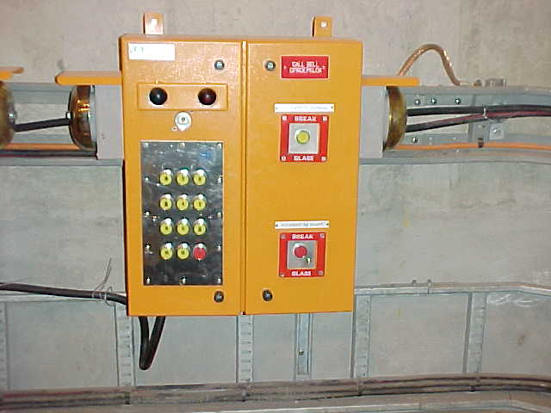

**NOTE:**

# Who may give signals?

1. The banksman and onsetter on duty to lower and raise persons.

2. When they are not available, a competent person permitted by the manager.

3. The ganger or miner in charge at the bottom of a shaft or wins in the course of being sunk, or a person under his direct supervision.

4. Any person duly authorised in writing by the manager to convey persons between the main mineral loading station and the lowest landing station.

###### Onsetter to have knowledge of shaft operations

* 1. No person shall be appointed as a banksman or onsetter, nor shall any person be authorised to give signals, unless such person has sufficient knowledge of the shaft operations and of the signals to be given in connection with such operations.

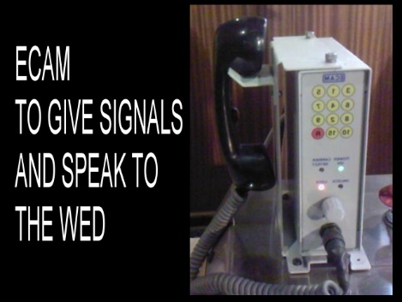

###### System for shaft examination

16.42.2 every shaft where persons travel on or in the conveyance while carrying out any examination, repair or other work shall be provided with some efficient means, approved by the Principal Inspector of Mines, whereby persons doing such examination or work can signal effectively from any depth in the shaft to the winding engine driver;

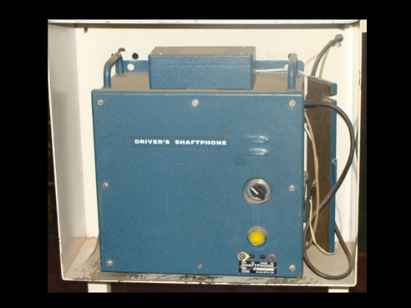

**E-Cam set:** is a two-way radio between persons on the winder conveyance in the shaft and the driver, they may talk or interchange signals with each other. The winding rope together with the two coils of the e-cam serves as an antenna.

The one coil is secured to the winding rope just above the conveyance which will serve as a transmitter “i-coil”, the receiver or “u-coil” is secured in the headgear above the spectacle-plate around the winding rope. Both antennas are connected to their respective E-cam sets, one on the conveyance and the other on the winder footplate. These e-cam sets are powered by re-chargeable batteries, among their many features it warns the Driver that the batteries are going flat.

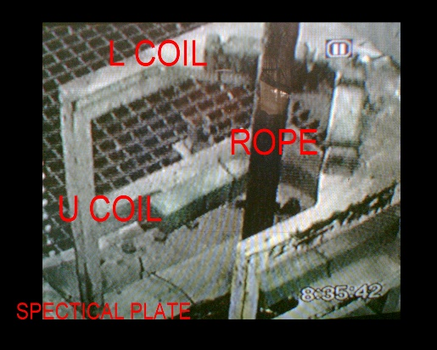

When there is more than one winder operating in the shaft, e-cam sets may be used simultaneously on each winder which will be set to operate on different frequencies thus ensuring that no mixing of signals occur.

Another feature of the e-cam includes a winder “brake-locked” facility (green button) when the Driver transmits a signal to the shaft conveyance the brakes will become locked in the “on position” it will be necessary to obtain a signal from the person on the conveyance to un-lock the winder brakes before the winder could be moved.

On the conveyance e-cam unit a “Red button emergency trip switch” is provided to allow persons to trip the winder safety circuit in cases of emergency during shaft examination or repairs.

The driver can only act on signals received from the e-cam set and not by means of verbal instructions.

**Contact wire**. is a stranded copper wire running down the length of the shaft from the collar at the bank to the bottom, to form part of a circuit? The copper wire is carried on insulators, and is used to transmit signals from any point in the shaft. The person on the conveyance uses a contact file to touch the copper wire to complete the circuit to activate a bell at the driver. The driver can hear the signal, but the person on the conveyance cannot hear the signals, and the driver cannot transmit a signal to the person on the conveyance. The person on the conveyance is compelled to signal 4 pause 1, and a 4 pause 2 as movement signals. Some of the contact wire systems are so arranged that the driver can reply a signal after applying the brakes. By doing this he activates the bell-brake interlock, locking the winder’s brakes. By touching the contact wire with the file by the person on the conveyance, the brakes are unlocked.

**Contact wire**

**Pull-bell.**

This system can be used in shaft sinking and in shaft examination. It is a thin cable from the top to the bottom of the shaft. At the top it is connected to a weight with a pivot and it is anchored at the bottom. When the person on the conveyance pull the cable it lifts the weight, close a contact to alarm a signal on the drivers footplate. The driver can only receive, and not transmit a signal.

**Pull-bell.**

###### Electric signalling system

16.43 At every shaft and wins, other than a shaft or wins in the course of being sunk, where persons are regularly conveyed and where the signalling arrangements are operated by electricity, the following provisions, except as is provided for regulation 16.44, shall be observed in respect of each winding plant used for the raising or lowering of persons: -

16.43.1 There shall be provided and maintained in good working order 2 separate, independent, and efficient signalling arrangements, hereinafter referred to as the locked-bell system and the call-bell system, which shall be used for transmitting signals.



###### Locked bell system

16.43.2 The locked-bell system shall be for the interchange of signals between -

(a) The winding-engine driver and the bank, and

(b) The winding engine driver and every established point below the bank from which winding is normally carried on, but it shall not enable the banksman to signal on this system to anyone but the winding engine driver.

* + 1. The system shall be arranged so that the winding engine driver can easily distinguish between signals received from the bank and signals received from below the bank.

**Men Switch Material Switch____**

On Lock bell 10 sec delay brakes On Lock bell no delay on brakes

Trips lower (men overwind / men under wind) Trips higher (material under wind/overwind)

Acknowledgement on lock bell all signals Acknowledgement on lock bell signal 1

Speed in shaft with winder slower Speed in shaft with winder faster

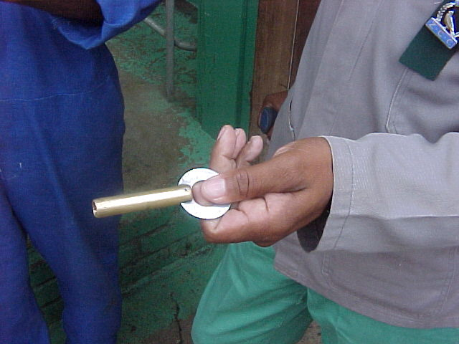

**Lock-bell system**

Consist of a Bank and shaft lock-bell system.

Bank lock bell enables the driver to transmit signals to the banksman, and the banksman to the driver.

Shaft lock bell enables the driver to transmit signals to every established landing station below the bank, and the onsetter to the driver from every landing station below the bank.

Banksman cannot interfere with shaft lock-bell system, but he can hear the onsetter signals on the tell-tail-bell, situated on the bank.

They must only use one key per system; the keys are deferent in shape.

There are robot lights on the station and at the bank to indicate when the winder’s brakes are locked or unlocked. When the driver gives a signal the system is locked and the lights on the station or bank is green and it is safe to have access to the conveyance. When the onsetter or banksman signals to the driver the system is unlocked and the robot light is red and it not safe to have access to the conveyance. There is deference between the tone of the bank and the underground bell.

You only remove your key when the conveyance has departed, in case someone wants to enter conveyance after you rang away.

**

###### Locking of signal mechanism

* + 1. The system shall further be arranged and maintained so as to prevent as far as possible signals being given by unauthorised persons. The signal operating mechanism at the bank and at all points below the bank shall be kept securely enclosed in a metal casing of substantial construction and shall be kept locked when not in actual use. The key shall be removed and when not required shall be removed and retained by the banksman, onsetter or other authorised person: Provided that other locking arrangements may be used if approved by Principal Inspector of Mines.

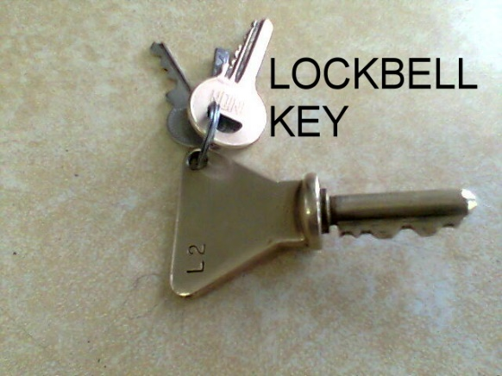

**Call-bell system**

16.43.6 The call-bell system shall enable signals to be transmitted -

(a) To the winding engine driver from the bank, and

(b) To the winding engine driver from every established point below the bank from which winding is normally carried on, and shall also enable signals to be interchanged between the bank and every established point below the bank from which winding is normally carried on, but it shall not enable the winding engine driver to transmit signals on this system.

Any person can activate this system. You can get a mechanical and electrical system.

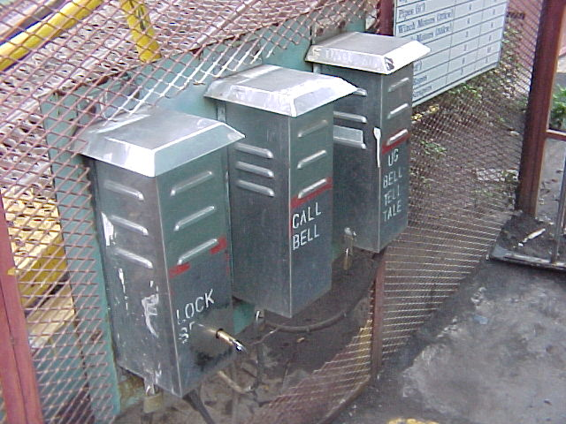

### It is used for: 1. Accident to shaft – one long ring

**2. Accident to person – 10 followed by the station signal.**

A manual system, in case of one long ring, must be activated until all winding has stopped. It can also be used to prevent an accident to shaft, and not only when the accident already took place. An automatic winder will trip out if it is activated.

###### Accessibility of call-bell

* + 1. The signal operating mechanism of the call-bell system shall be accessible to any person to transmit the signals “10 followed by a station signal” and “one long ring” referred to in regulation 16.45, but it shall not be used for any other purpose: Provided that the banksman or onsetter or any other person duly authorised by the manager may use the system to indicate the station at which the conveyance is required and subject to the approval of the regional director to transmit special signals.

###### Tone of bells

16.43.8 The tone of the bells of the call-bell system shall be such as to be easily distinguishable from that of the bells of the locked-bell system.

###### Telephone in place of call-bell

16.43.9 In a shaft or winze where efficient telephonic intercommunication is provided between the bank and every established landing station for persons below the bank, it shall be necessary to provide only one call-bell system in respect of all the windings plants serving such shafts or wins.

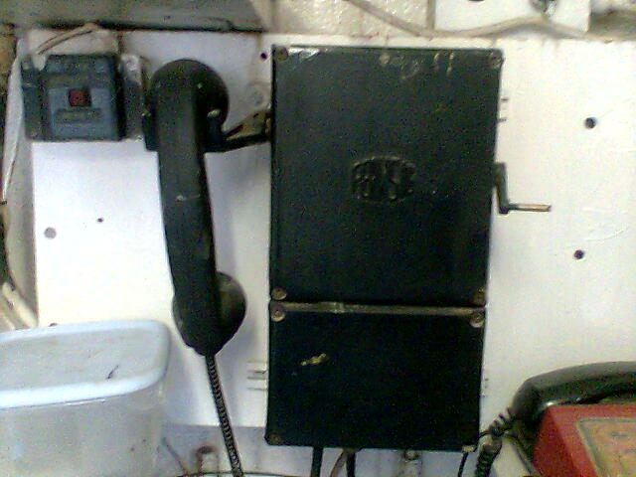

###### Other systems - approval

16.44 Signalling arrangements other than those required by regulation 16.43 may be used with the written approval of the Principal Inspector of Mines.

**Intercommunicating bell**

**The functioning and principles of operation of the intercommunication bell system.**

**Inter communication bell:**

**-** is not a legal requirement but once installed it must be kept in working order.

Should a Driver receive an “accident to shaft” signal s/he will transmit a long ring on the intercommunication bell system to warn the other Drivers to stop all winding in the shaft. When more than one winder is operating in the shaft, an intercommunication bell system is installed on each winder footplate.

**Telephone**

Between the banksman and the onsetter, and between the driver.

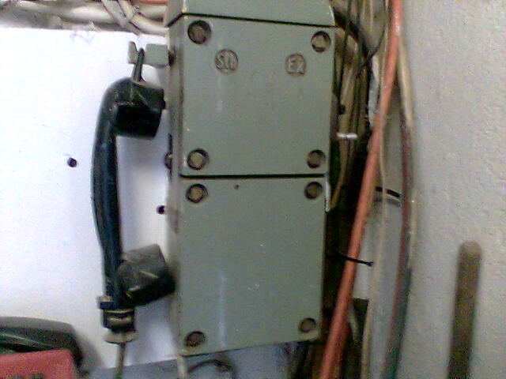

**Intercom**

Between winding engine drivers.

###### Code of signals

16.45 The following code of signals shall be used and strictly observed where a winding plant is operated at a shaft or winze where persons are regularly allowed to ride:

Knocks or rings –

1……………….………………. Raise when engine at rest.

1 ………………………………. Stop when engine in motion.

2 ………………………………. Lower.

3 ………………………………. Persons about to travel.

3 ………………………………. In reply: Persons may continue to travel or may enter the cage or other conveyance for the purpose of travelling.

3 ………………………………. From engine driver when cage or other conveyance containing persons is brought to rest at a station: Persons may leave the cage or other conveyance

2 pause 2 ………………………. From driver (clear signal requested): Driver wishes to start the winding engine at his discretion.

2 pause 2 ………………………. To driver (clear signal): Driver may start the winding engine at his discretion.

2 pause 2 pause 2 ……………… From driver: Persons must leave the conveyance.

2 pause 2 pause 2 ……………… In reply: No persons in the conveyance.

2 pause 2 pause 2 pause 2 ……. Cancel or repeat signal.

3 pause 3 pause 3 ……………… Person giving signals about to travel.

3 pause 3 pause 3 ……………… In reply: Acknowledgement by driver that person signalling is about to travel.

4 pause 1 ………………………. Raise slowly.

4 pause 2 ………………………. Lower slowly.

4 pause 4 ………………………. To driver: Mark signal.

4 pause 4 ………………………. In reply: Acknowledgement by driver of “mark” signal.

4 pause 4 pause 4 ……………… To driver: Clutching signal.

4 pause 4 pause 4 ……………… In reply: Clutching operations completed.

5 pause 5 ………………………. To driver: Explosives about to be placed in the conveyance. (per deck)

5 pause 5 ………………………. In reply: Explosives may be placed in the conveyance. (per deck)

5 pause 5 ………………………. From driver when conveyance-containing explosives is brought to rest at station; explosives may be removed from the conveyance.

5 pause 5 pause 5 ……………… To driver: No explosives in the conveyance.

5 pause 5 pause 5 ……………… In reply: Acknowledgement by driver that there are no explosives in the conveyance.

6 pause 6 ………………………. To driver: Winding compartments served by engine locked.

6 pause 6 ………………………. In reply: Acknowledgement by driver of “compartments locked”

6 pause 6 followed by

Station signal. To driver: Winding compartments served by engine locked below station designated.

6 pause 6 followed by

Station signal ………………… in reply: Acknowledgement by driver of “compartments locked below station designated” signal.

6 pause 6 pause 6 ……………… To driver: Compartments served by engine re-opened.

6 pause 6 pause 6 ……………… In reply: Acknowledgement by driver of” compartments served by engine re-opened” signal.

6 pause 6 pause 6 pause 6 ……. To driver: Shaft examination and repairs about to take place.

6 pause 6 pause 6 pause 6 ……. In reply: Acknowledgement by driver “shaft examination and repairs” signal.

7 ……………………………….. To driver: Persons about to have access to the conveyance for a purpose other than travelling or the loading or unloading of mineral in trucks or of material.

7 ……………………………….. In reply: Persons may have access to the conveyance for a purpose other than travelling or the loading or unloading of mineral in trucks or of material.

7 pause 7 ………………………. To driver: Conveyance is clear of all persons who have had access to it for a purpose other than travelling or the loading of mineral in trucks or of material.

7 pause 7 ………………………. In reply: Acknowledgement by driver of “persons clear” signal.

15 ……………………………… Electrician testing bells.

15 …………………………….. In reply: Acknowledgement of “bell testing” signal.

15 pause 2pause 2 ……………. Electrician has completed test.

10 followed by station signal … Accident to person: station where conveyance is required.

1 long ring ……………………. Accident to shaft: Winding operations to be suspended immediately in all compartments of the shaft.

In any purely mechanical signalling system “continued ringing”

Shall replace “one long ring” for the “accident to shaft” signal.

When raising or lowering mineral in trucks or material:

Knocks or rings –

8 ………………………………. To driver: raising or lowering of mineral in trucks or of material about to commence.

8……………………………….. In reply: Acknowledgement by driver that raising or lowering of mineral in trucks or of material is about to commence.

1………………………………. From driver: Persons may have access to conveyance for the purpose of loading or unloading mineral in trucks or material.

8 pause 8 ……………………… To driver: Raising or lowering of mineral in trucks or of material completed.

8 pause 8 ……………………… In reply: Acknowledgement by driver that raising or lowering of mineral in trucks or of material is completed.

**Special signals.**

16.46 In addition to the foregoing signals, special signals may be used provided they have been approved in writing by the Principal Inspector of Mines.

**Code to be posted up.**

16.49.1 The code of signals referred to in regulation 16.45 or an abridged form thereof approved by the Director General, as well as the special signals that may be in use on a mine, shall be displayed suitably in the form of distinctly legible notices in letters and figures not less than ten millimetres in height. The decision whether such notices are suitably displayed and distinctly legible shall rest with the Regional Director. Such notices shall be posted up in the winding engine room, at the bank and at all shaft or winze stations for the time being in use.